C4 model portfolio

Introduction

To help me with organizing the different parts and pages of my portfolio, I made a C4 model after also the feedback from the teachers. This model shows me which parts I want in my website in a clear overview.

I started by looking at the website of C4 model to understand what a C4 model is and how to make it (C4 Model, n.d.).

C4 Model

Below you can see the C4 model. Here you can see which pages my portfolio has and which page refers to which page.

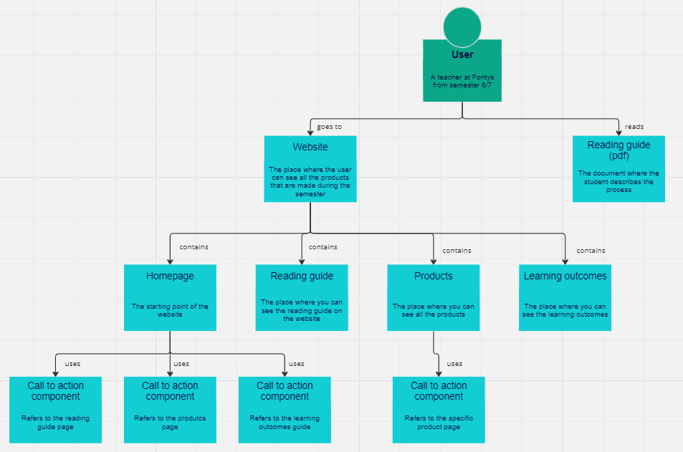

Conclusion

Due to making the C4 model I now have a better overview of my portfolio. This also ensures that I won't miss a page when I’m coding it.

# Bibliography

C4 Model. (n.d.). *The C4 model for visualising software architecture*. Retrieved December 30, 2023, from <https://c4model.com/>